**Decision Making statements**

**CODE:**

#include <iostream>

using namespace std;

int main() {

int year;

cout << "Enter a year: ";

cin >> year;

if ((year % 4 == 0 && year % 100 != 0) || year % 400 == 0) {

cout << year << " is a leap year.";

}

else {

cout << year << " is not a leap year.";

}

return 0;

}

**OUTPUT:**

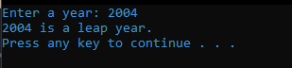

**Armstrong Number**

**CODE:**

#include<iostream>

#include<conio.h>

#include<math.h>

using namespace std;

void main()

{

int num,on;

int res=0,rem;

clrscr();

cout<<"Ansari Midhat-210403\n";

cout<<"Enter a 3 digit no:";

cin>>num;

on=num;

while(on!=0)

{

rem=on%10;

res=res+pow(rem,3);

on=on/10;

}

if(res==num)

cout<<num<< " is an armstrong no";

else

cout<<num<< "is not an armstrong no";

getch();

}

**OUTPUT:**

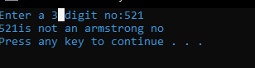

**Palindrome:**

**CODE:**

#include<iostream>

#include<conio.h>

using namespace std;

int main()

{

int n,num,digit,i;

int rev=0;

cout<<"Enter a no:";

cin>>n;

n=num;

for(i=0;num!=0;i++)

{

digit=num%10;

rev=rev*10+digit;

num=num/10;

}

if(n==rev)

cout<<"No. is palindrome";

else

cout<<"No. is not a palindrome";

return 0;

}

**OUTPUT:**

